Official Registration Form 2022
Start & Finish Line – Broughton Astley Conservative Club
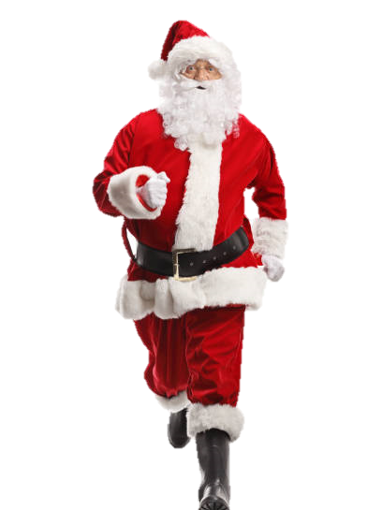
Start Time – 9:45 am Warm Up, 10:00 staggered start in groups
Route – 3 km or 5 km (details available from our Facebook Page)
Parking – Please use the Co-Op car park in the village

Santa suits are available for collection from the White Horse car park on
Saturday 26th & Sunday 27th November (between 3:00 pm and 5:00 pm), at
the Christmas Fayre (between 4:00 pm and 7:30 pm), and from the Dash and
Dawdle start line on Sunday 4th November from 9:15 am
You will be given a unique collection number. Postal entries and cheques (made
payable to Broughton Alive) should be sent to 36 Richardson Close, Broughton Astley,
Leics, LE9 6NU. Entries for The Santa Dash and Dawdle can also be made at the
Christmas Fayre or the morning of the run. For email entries please contact santadashanddawdle@gmail.com

Your Name : …………………………………………………………………………………………
Run, Jog, Dash or Dawdle
Each participant needs to complete a separate registration form
Address : ..………………………………………………………………………………………
Mobile : ………………………………………………………………………………………..
Email : …………………………………………………………………………………………
Please Tick Your Category :
Adult £10.00 | Child (ages 7 -12) £5.00 | Infant (Under 7) Free
Family (2 + 2) £25.00 | Bring Your Own Santa Suit £5.00
For group bookings, please contact Jane 07702 085989 or Jo 07909 988494

Declaration (Please tick, date and sign. Under 16s must be counter signed by a responsible adult)
I declare that I am medically fit to take part in The Santa Dash and Dawdle 2022, and I understand that I am entering this event at my own risk. I understand that the organisers cannot be held responsible for any injury or illness incurred during or as a result of my participation in The Santa Dash and Dawdle, or for any property lost, stolen or damaged. I agree to abide by the Highway Code and event rules as displayed at the start/finish line.
Signed : …………………………………………………… | Date : ………………………………………………………

Volunteer
I would like to volunteer to help at The Santa Dash and Dawdle 2022
I would like to volunteer to help at Other Broughton Alive events
Your Name : ………………………………………………………………………………………………………………………
Email : ………………………………………………………………………………………………………………………
Mobile Number : ……………………………………………………………………………………………………………………….

